TC_02_Validate that EDIS should throw exception error if source input (JSON) is not having any of following fields/fields data in process source JSON.

{"_id":"CustomerPreferences_53beca6f-a422-4747-9f4f-34deee54e2e5","aggregateId":"53beca6f-a422-4747-9f4f-34deee54e2e5","aggregateType":"CustomerPreferences","state":{"_class":"PreferenceAggregateDomain_v1","createTimestamp":1618517344707,"lastUpdateTimestamp":1618517344716,"createClientId":"web-portal","lastUpdateClientId":"web-portal","createHostName":"69e80177-e95a-4814-6ba3-6abe","lastUpdateHostName":"69e80177-e95a-4814-6ba3-6abe","aggregateId":"53beca6f-a422-4747-9f4f-34deee54e2e5","aggregateType":"CustomerPreferences","sequenceNumber":4,"timestamp":1522311151333,"aggregateRevision":4,"version":1,"eventId":"15dc2d76-8aa1-4ae1-bcb2-1418febc0ff2","preferences":[{"_class":"BasicPreferenceAggregateDomain_v1","preferenceId":1,"value":"CO","categoryCode":"SHOPPING_LIST","subCategoryCode":"J4U","preferredInd":0,"bannerId":"6","platform":2,"lastUpdatedTimestamp":1522311151000},{"_class":"BasicPreferenceAggregateDomain_v1","preferenceId":2,"value":"A","type":"MY_LIST","categoryCode":"DISPLAY","subCategoryCode":"SORT","preferredInd":1,"bannerId":"1","platform":1,"lastUpdatedTimestamp":1522311151000},{"_class":"BasicPreferenceAggregateDomain_v1","preferenceId":3,"value":"ME","type":"ITEMS_PER_PAGE","categoryCode":"DISPLAY","subCategoryCode":"PAGINATION","preferredInd":0,"bannerId":"6","lastUpdatedTimestamp":1522311151000},{"_class":"BasicPreferenceAggregateDomain_v1","preferenceId":4,"type":"2","categoryCode":"DISPLAY","subCategoryCode":"HIDDEN_CATEGORY","preferredInd":0,"bannerId":"6","lastUpdatedTimestamp":1522311151000,"optChoices":[{"_class":"OptChoiceAggregateDomain_v1","choice":"1","channel":1}]}]}}

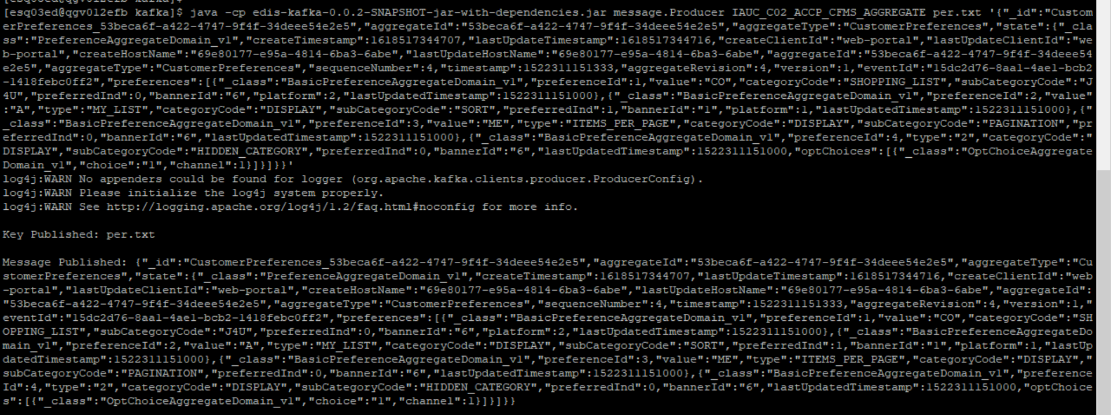



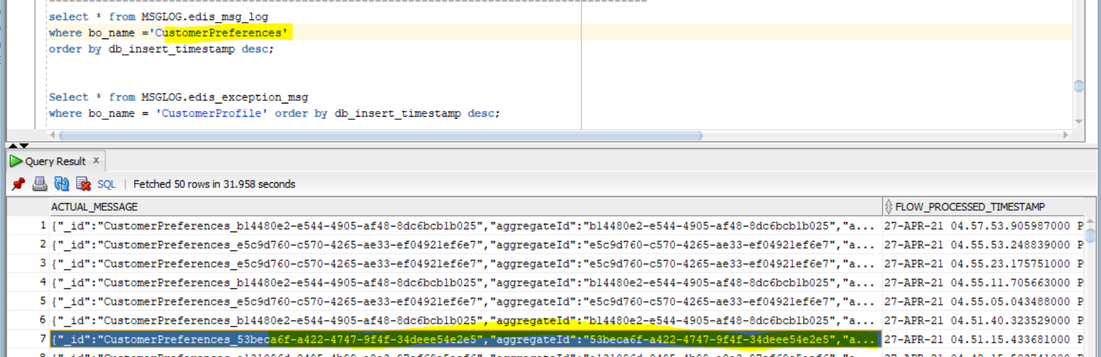

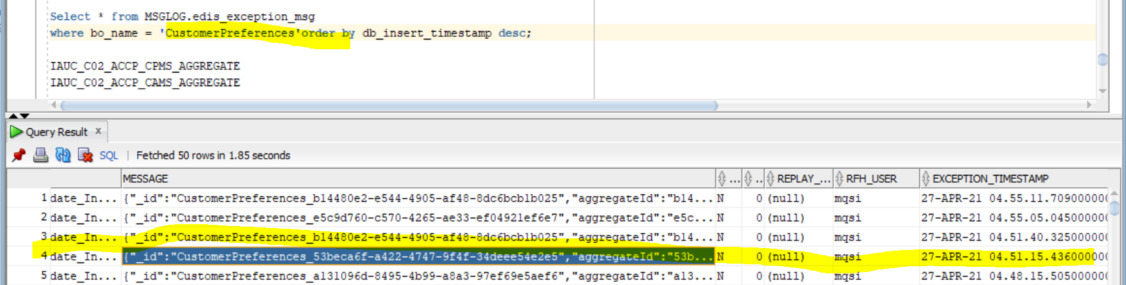

Exception Error-

abs.uca.cfms.ESED_CustomerPreferences_UCA_IH_Publisher.Audit_Validate_Input.Input_Audit_Compute Node threw an Exception . Error detected, rethrowing (com.abs.cmnflows.Audit_Validate_Input_Compute.Main, 133.4, PROPAGATE TO TERMINAL 'out' FINALIZE DEFAULT DELETE NONE;). Caught exception and rethrowing (com.abs.uca.cfms.ESED_CustomerPreferences_UCA_IH_Publisher.ESED_CFMS_CMM_Transformer.Compute). Error detected, rethrowing (com.abs.uca.cfms.ESED_CFMS_CMM_Transformer_Compute.Main, 141.8, THROW EXCEPTION CATALOG 'Illegal_Input_Message' MESSAGE 2951 VALUES('Mandatory field missing: preferenceDefId');). User generated exception (Mandatory field missing: preferenceDefId)

Scenarios:-2

{"_id":"CustomerPreferences_b14480e2-e544-4905-af48-8dc6bcb1b027","aggregateId":"b14480e2-e544-4905-af48-8dc6bcb1b027","aggregateType":"CustomerPreferences","state":{"_class":"PreferenceAggregateDomain_v1","createTimestamp":1615802584469,"lastUpdateTimestamp":1619564271210,"createClientId":"mobile-ios-shop","lastUpdateClientId":"mobile-ios-shop","createHostName":"3e148ada-52a4-498e-7a58-70ef","lastUpdateHostName":"33977bf1-8861-48e3-48bc-a2b4","aggregateId":"b14480e2-e544-4905-af48-8dc6bcb1b027","aggregateType":"CustomerPreferences","sequenceNumber":5884,"timestamp":1619564271147,"aggregateRevision":5884,"version":1,"eventId":"2b4f5685-645f-47aa-a7cb-158b5c2bd2bb","preferences":[{"_class":"BasicPreferenceAggregateDomain_v1","preferenceId":1,"type":"EMAIL_SAVE","categoryCode":"COMMUNICATION","subCategoryCode":"PROMOTIONAL","preferredInd":null,"lastUpdatedTimestamp":1619545323770,"optChoices":[{"_class":"OptChoiceAggregateDomain_v1","choice":"OPT_OUT"}]},{"_class":"BasicPreferenceAggregateDomain_v1","preferenceId":2,"type":"J4U","categoryCode":"COMMUNICATION","subCategoryCode":"PROMOTIONAL","preferredInd":null,"preferenceDefId":"15dc2d76-8aa1-4ae1-bcb2-1418febc0ff2","lastUpdatedTimestamp":1619545321123,"optChoices":[{"_class":"OptChoiceAggregateDomain_v1","choice":"OPT_OUT"}]}]}}

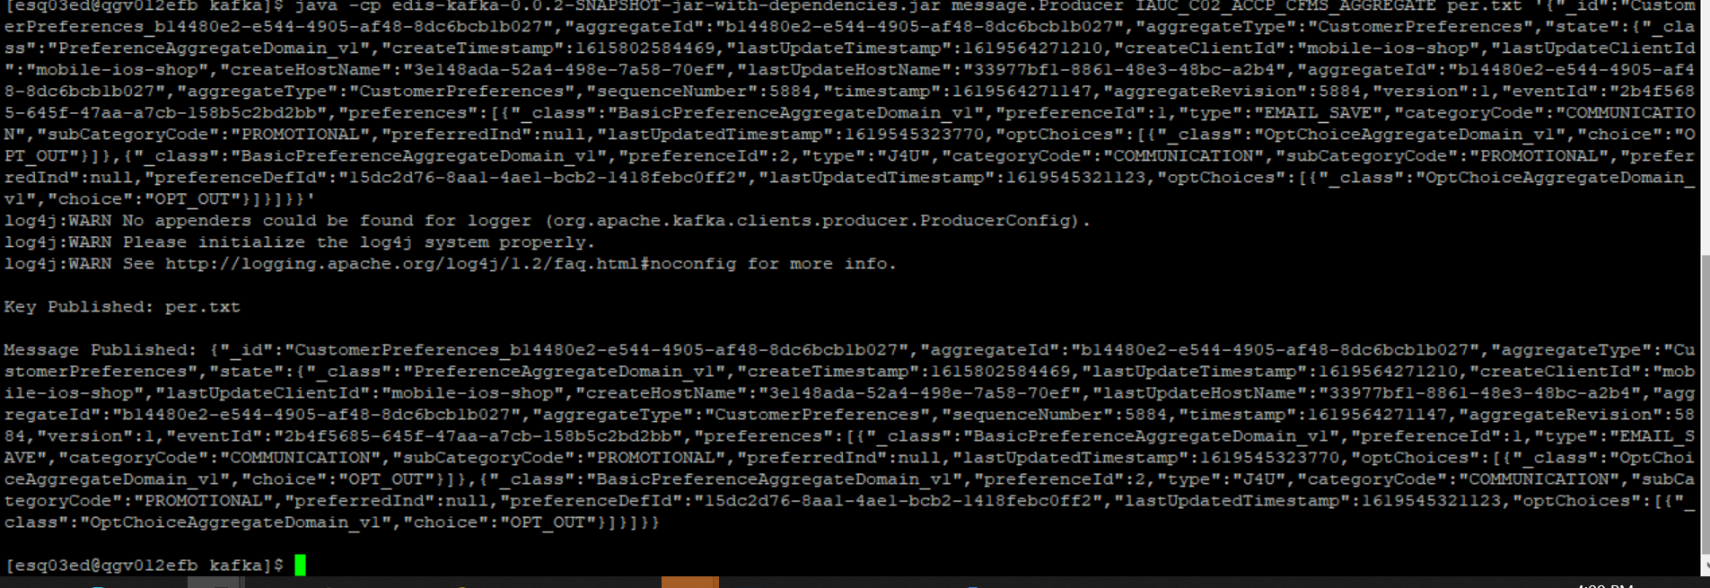



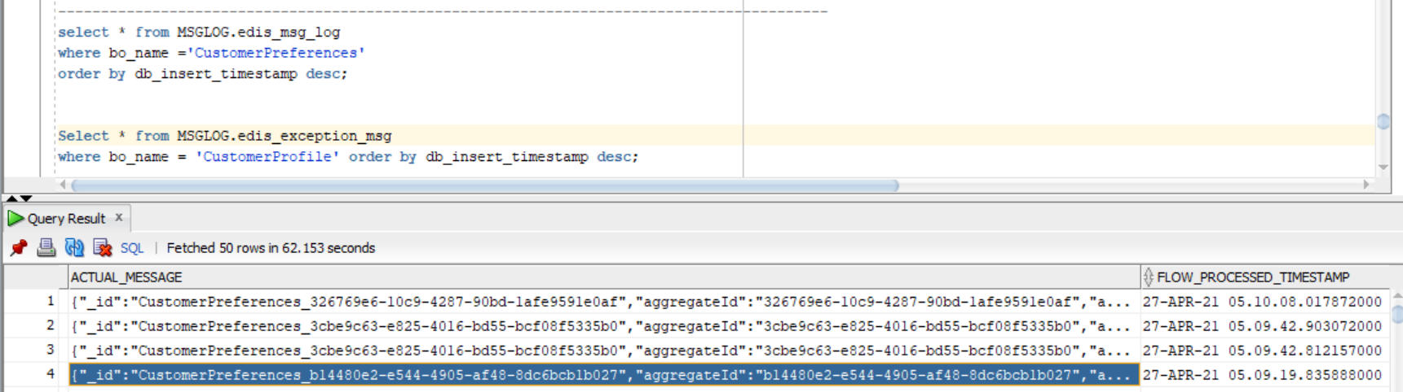

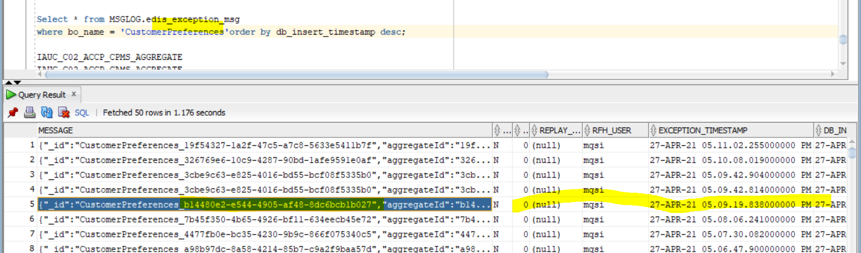

Exception Error-

abs.uca.cfms.ESED_CustomerPreferences_UCA_IH_Publisher.Audit_Validate_Input.Input_Audit_Compute Node threw an Exception . Error detected, rethrowing (com.abs.cmnflows.Audit_Validate_Input_Compute.Main, 133.4, PROPAGATE TO TERMINAL 'out' FINALIZE DEFAULT DELETE NONE;). Caught exception and rethrowing (com.abs.uca.cfms.ESED_CustomerPreferences_UCA_IH_Publisher.ESED_CFMS_CMM_Transformer.Compute). Error detected, rethrowing (com.abs.uca.cfms.ESED_CFMS_CMM_Transformer_Compute.Main, 141.8, THROW EXCEPTION CATALOG 'Illegal_Input_Message' MESSAGE 2951 VALUES('Mandatory field missing: preferenceDefId');). User generated exception (Mandatory field missing: preferenceDefId)

Scenario-3 "preferredInd":null, then CMM xml should be generate.

{"_id":"CustomerPreferences_b14480e2-e544-4905-af48-8dc6bcb1b027","aggregateId":"b14480e2-e544-4905-af48-8dc6bcb1b027","aggregateType":"CustomerPreferences","state":{"_class":"PreferenceAggregateDomain_v1","createTimestamp":1615802584469,"lastUpdateTimestamp":1619564271210,"createClientId":"mobile-ios-shop","lastUpdateClientId":"mobile-ios-shop","createHostName":"3e148ada-52a4-498e-7a58-70ef","lastUpdateHostName":"33977bf1-8861-48e3-48bc-a2b4","aggregateId":"b14480e2-e544-4905-af48-8dc6bcb1b027","aggregateType":"CustomerPreferences","sequenceNumber":5884,"timestamp":1619564271147,"aggregateRevision":5884,"version":1,"eventId":"2b4f5685-645f-47aa-a7cb-158b5c2bd2bb","preferences":[{"_class":"BasicPreferenceAggregateDomain_v1","preferenceId":1,"type":"EMAIL_SAVE","categoryCode":"COMMUNICATION","subCategoryCode":"PROMOTIONAL","preferredInd":null,"preferenceDefId":"15dc2d76-8aa1-4ae1-bcb2-1418febc0ff2","lastUpdatedTimestamp":1619545323770,"optChoices":[{"_class":"OptChoiceAggregateDomain_v1","choice":"OPT_OUT"}]},{"_class":"BasicPreferenceAggregateDomain_v1","preferenceId":2,"type":"J4U","categoryCode":"COMMUNICATION","subCategoryCode":"PROMOTIONAL","preferredInd":null,"preferenceDefId":"15dc2d76-8aa1-4ae1-bcb2-1418febc0ff3","lastUpdatedTimestamp":1619545321123,"optChoices":[{"_class":"OptChoiceAggregateDomain_v1","choice":"OPT_OUT"}]}]}}

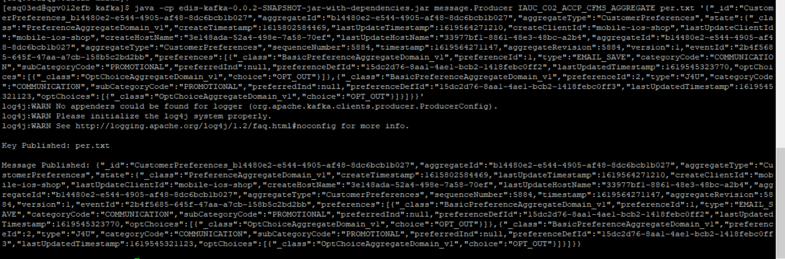



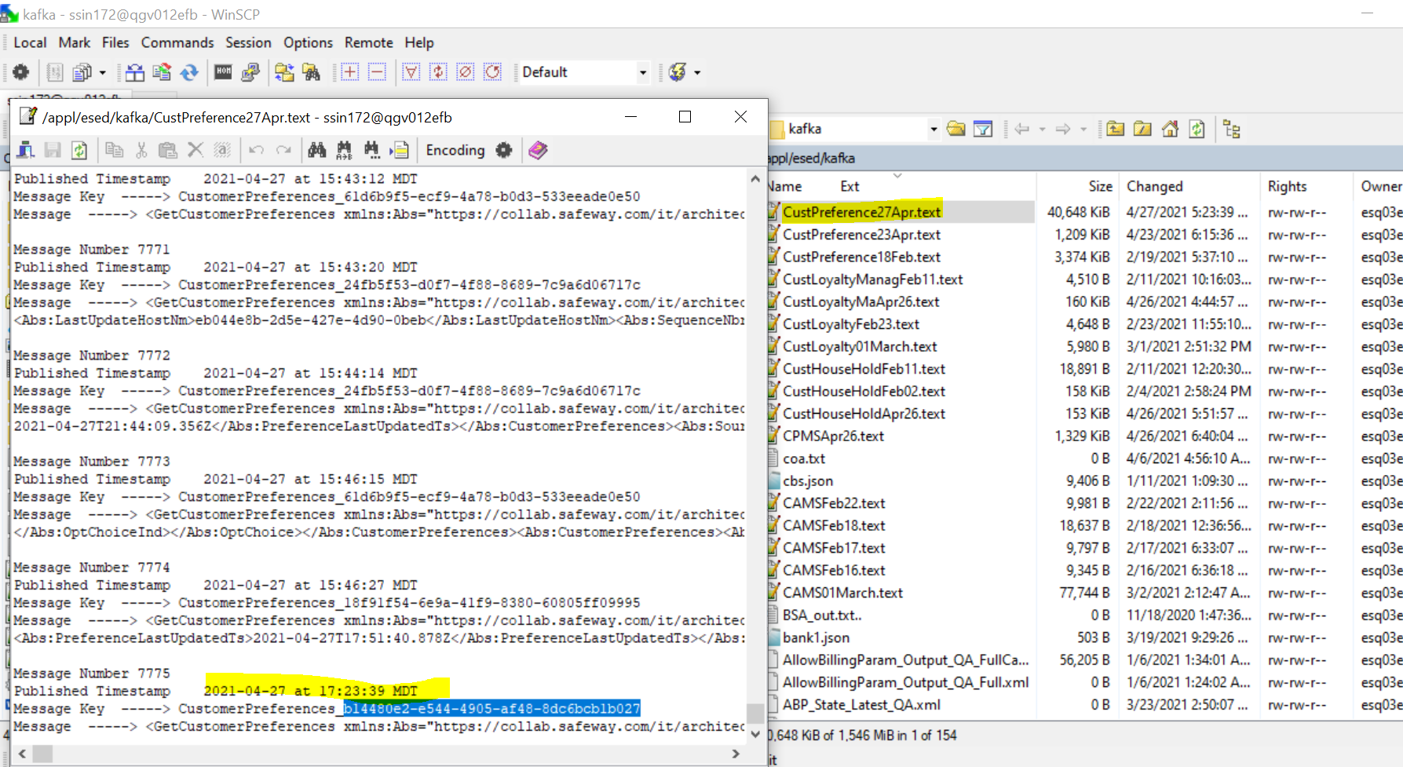

CMM xml-

<GetCustomerPreferences

xmlns:Abs="https://collab.safeway.com/it/architecture/info/default.aspx">

<DocumentData>

<Document VersionId="v4.1.1" SystemEnvironmentCd="QA">

<Abs:DocumentID>IAUC_C02_ACCP_CFMS_AGGREGATE</Abs:DocumentID>

<Abs:AlternateDocumentID>IAUC_C02_ACCP_CFMS_AGGREGATE_1_51248_20210427172339614956</Abs:AlternateDocumentID>

<Abs:InboundOutboundInd>Outbound from Albertsons</Abs:InboundOutboundInd>

<Abs:DocumentNm>CustomerPreferences</Abs:DocumentNm>

<Abs:CreationDt>2021-04-27T17:23:39.614956</Abs:CreationDt>

<Abs:Description>CustomerPreferencesData</Abs:Description>

<Abs:SourceApplicationCd>UCA</Abs:SourceApplicationCd>

<Abs:TargetApplicationCd>EDIS</Abs:TargetApplicationCd>

<Abs:InternalFileTransferInd>Y</Abs:InternalFileTransferInd>

<Abs:DataClassification>

<Abs:DataClassificationLevel>

<Abs:Code>Internal</Abs:Code>

</Abs:DataClassificationLevel>

<Abs:BusinessSensitivityLevel>

<Abs:Code>Low</Abs:Code>

</Abs:BusinessSensitivityLevel>

<Abs:PHIdataInd>N</Abs:PHIdataInd>

<Abs:PCIdataInd>Y</Abs:PCIdataInd>

<Abs:PIIdataInd>Y</Abs:PIIdataInd>

</Abs:DataClassification>

</Document>

<DocumentAction>

<Abs:ActionTypeCd>UPDATE</Abs:ActionTypeCd>

<Abs:RecordTypeCd>CHANGE</Abs:RecordTypeCd>

</DocumentAction>

</DocumentData>

<CustomerPreferencesData>

<Abs:CustomerId>b14480e2-e544-4905-af48-8dc6bcb1b027</Abs:CustomerId>

<Abs:CustomerPreferences>

<Abs:PreferenceCd>1</Abs:PreferenceCd>

<Abs:PreferenceTypeCd>

<Abs:Code>EMAIL_SAVE</Abs:Code>

</Abs:PreferenceTypeCd>

<Abs:PreferenceDefinitionId>15dc2d76-8aa1-4ae1-bcb2-1418febc0ff2</Abs:PreferenceDefinitionId>

<Abs:PreferenceCategoryCd>COMMUNICATION</Abs:PreferenceCategoryCd>

<Abs:PreferenceSubCategoryCd>PROMOTIONAL</Abs:PreferenceSubCategoryCd>

<Abs:PreferredInd></Abs:PreferredInd>

<Abs:PreferenceLastUpdatedTs>2021-04-27T17:42:03.770Z</Abs:PreferenceLastUpdatedTs>

<Abs:OptChoice>

<Abs:OptChoiceInd>OPT_OUT</Abs:OptChoiceInd>

</Abs:OptChoice>

</Abs:CustomerPreferences>

<Abs:CustomerPreferences>

<Abs:PreferenceCd>2</Abs:PreferenceCd>

<Abs:PreferenceTypeCd>

<Abs:Code>J4U</Abs:Code>

</Abs:PreferenceTypeCd>

<Abs:PreferenceDefinitionId>15dc2d76-8aa1-4ae1-bcb2-1418febc0ff3</Abs:PreferenceDefinitionId>

<Abs:PreferenceCategoryCd>COMMUNICATION</Abs:PreferenceCategoryCd>

<Abs:PreferenceSubCategoryCd>PROMOTIONAL</Abs:PreferenceSubCategoryCd>

<Abs:PreferredInd></Abs:PreferredInd>

<Abs:PreferenceLastUpdatedTs>2021-04-27T17:42:01.123Z</Abs:PreferenceLastUpdatedTs>

<Abs:OptChoice>

<Abs:OptChoiceInd>OPT_OUT</Abs:OptChoiceInd>

</Abs:OptChoice>

</Abs:CustomerPreferences>

<Abs:SourceAuditData>

<Abs:SourceNm>CustomerPreferences</Abs:SourceNm>

<Abs:CreateTs>2021-03-15T10:03:04.469Z</Abs:CreateTs>

<Abs:LastUpdateTs>2021-04-27T22:57:51.210Z</Abs:LastUpdateTs>

<Abs:CreateClientId>mobile-ios-shop</Abs:CreateClientId>

<Abs:LastUpdateClientId>mobile-ios-shop</Abs:LastUpdateClientId>

<Abs:CreateHostNm>3e148ada-52a4-498e-7a58-70ef</Abs:CreateHostNm>

<Abs:LastUpdateHostNm>33977bf1-8861-48e3-48bc-a2b4</Abs:LastUpdateHostNm>

<Abs:SequenceNbr>5884</Abs:SequenceNbr>

<Abs:AggregateTs>2021-04-27T22:57:51.147Z</Abs:AggregateTs>

<Abs:AggregateRevisionNbr>5884</Abs:AggregateRevisionNbr>

<Abs:PayloadVersionNbr>1</Abs:PayloadVersionNbr>

<Abs:EventId>2b4f5685-645f-47aa-a7cb-158b5c2bd2bb</Abs:EventId>

</Abs:SourceAuditData>

</CustomerPreferencesData>

</GetCustomerPreferences>

Scenario- : "aggregateId under state is not present in message. Should throw exception.

{"_id":"CustomerPreferences_b14480e2-e544-4905-af48-8dc6bcb1b029","aggregateId":"b14480e2-e544-4905-af48-8dc6bcb1b029","aggregateType":"CustomerPreferences","state":{"_class":"PreferenceAggregateDomain_v1","createTimestamp":1615802584469,"lastUpdateTimestamp":1619564271210,"createClientId":"mobile-ios-shop","lastUpdateClientId":"mobile-ios-shop","createHostName":"3e148ada-52a4-498e-7a58-70ef","lastUpdateHostName":"33977bf1-8861-48e3-48bc-a2b4","aggregateType":"CustomerPreferences","sequenceNumber":5884,"timestamp":1619564271147,"aggregateRevision":5884,"version":1,"eventId":"2b4f5685-645f-47aa-a7cb-158b5c2bd2bb","preferences":[{"_class":"BasicPreferenceAggregateDomain_v1","preferenceId":1,"type":"EMAIL_SAVE","categoryCode":"COMMUNICATION","subCategoryCode":"PROMOTIONAL","preferredInd":1,"preferenceDefId":"15dc2d76-8aa1-4ae1-bcb2-1418febc0ff2","lastUpdatedTimestamp":1619545323770,"optChoices":[{"_class":"OptChoiceAggregateDomain_v1","choice":"OPT_OUT"}]},{"_class":"BasicPreferenceAggregateDomain_v1","preferenceId":2,"type":"J4U","categoryCode":"COMMUNICATION","subCategoryCode":"PROMOTIONAL","preferredInd":null,"preferenceDefId":"15dc2d76-8aa1-4ae1-bcb2-1418febc0ff3","lastUpdatedTimestamp":1619545321123,"optChoices":[{"_class":"OptChoiceAggregateDomain_v1","choice":"OPT_OUT"}]}]}}

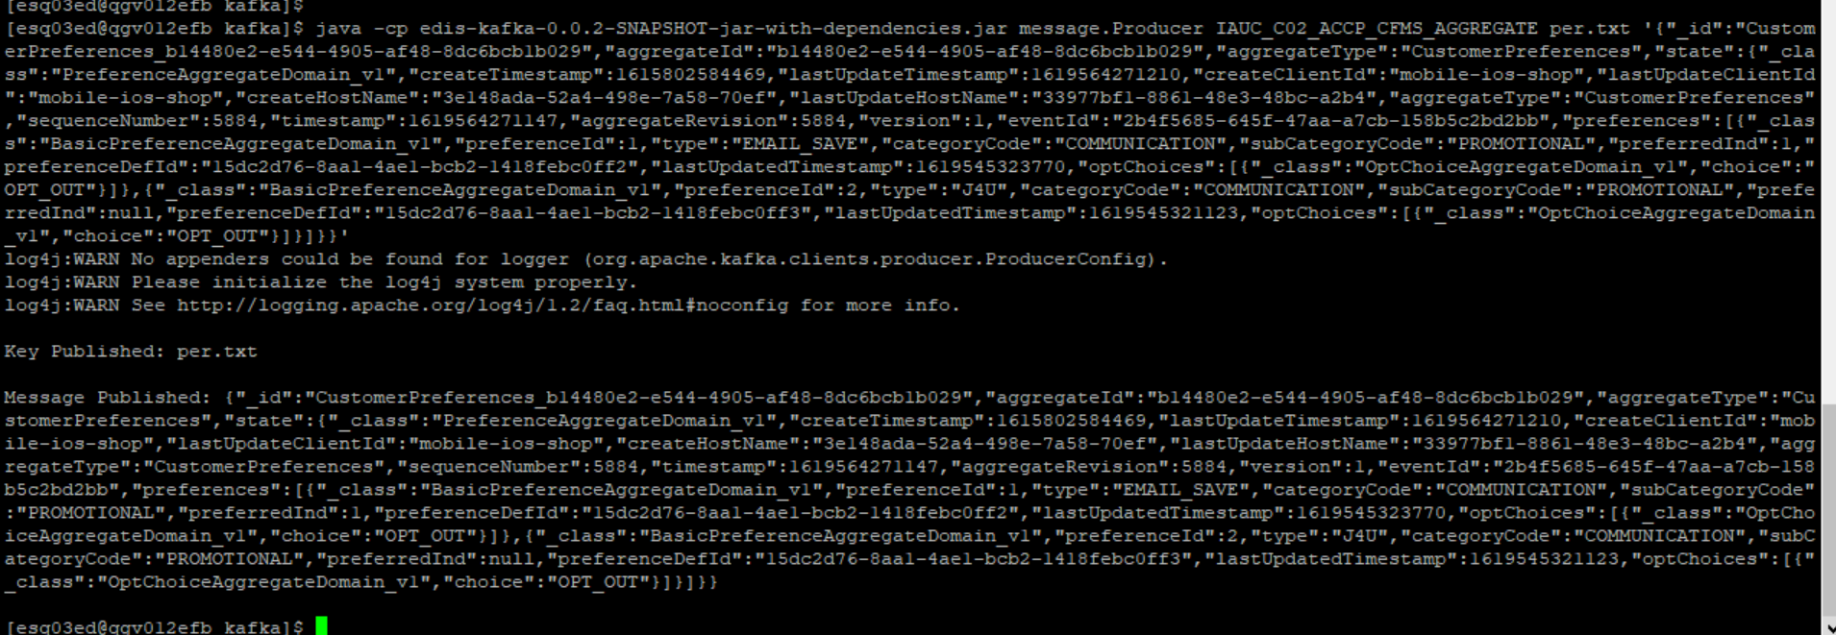



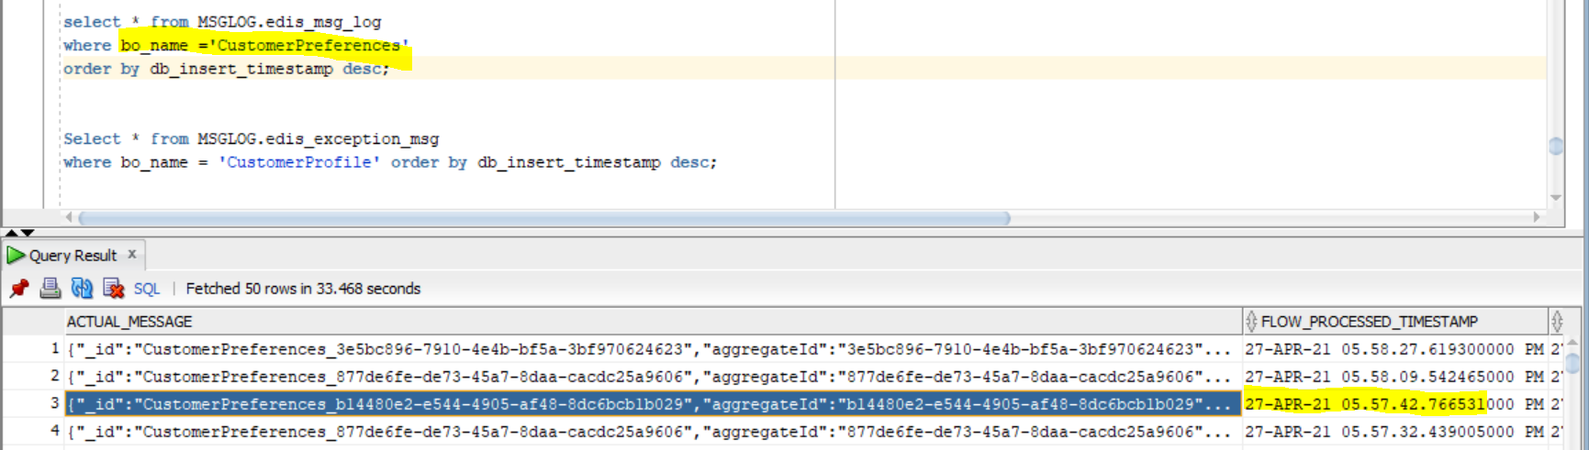

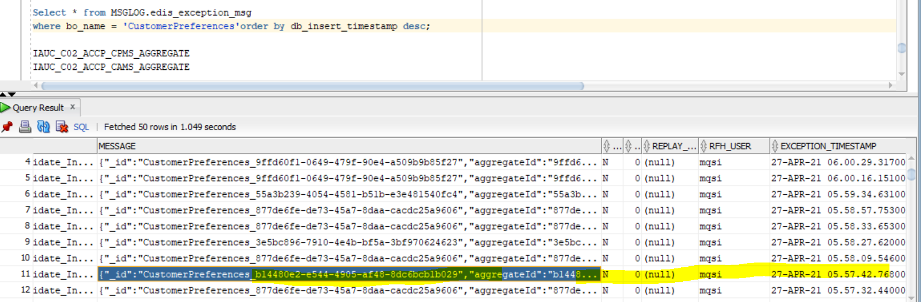

Exception Error-

abs.uca.cfms.ESED_CustomerPreferences_UCA_IH_Publisher.Audit_Validate_Input.Input_Audit_Compute Node threw an Exception . Error detected, rethrowing (com.abs.cmnflows.Audit_Validate_Input_Compute.Main, 133.4, PROPAGATE TO TERMINAL 'out' FINALIZE DEFAULT DELETE NONE;). Caught exception and rethrowing (com.abs.uca.cfms.ESED_CustomerPreferences_UCA_IH_Publisher.ESED_CFMS_CMM_Transformer.Compute). Error detected, rethrowing (com.abs.uca.cfms.ESED_CFMS_CMM_Transformer_Compute.Main, 102.6, THROW EXCEPTION CATALOG 'Illegal_Input_Message' MESSAGE 2951 VALUES('Mandatory field missing: aggregateId');). User generated exception (Mandatory field missing: aggregateId).